**M AND J KINDERGARTEN SCHOOL**

**END OF END EXAMINATION 2023**

**MIDDLE CLASS: (4 – 5 YEARS)**

**LEARNING AREA 1: SOCIAL DEVELOPMENT**

**My name is: …………………………………..………………………….**

**My School is: ……………………………..………….…………………..**

**I am in: ………………………………..………………………………………………..**

1. **Match the same words and write.**

lame pregnant woman ___________

blind old person ________________

deaf blind _______________

old person deaf _______________

pregnant woman lame ____________

1. **Cross out the same words.**

car box car

lorry lorry pen

bag train train

bus bus tree

1. **Read and draw.**

kite bird

insect aeroplane

1. **Circle and colour things made out of clay.**



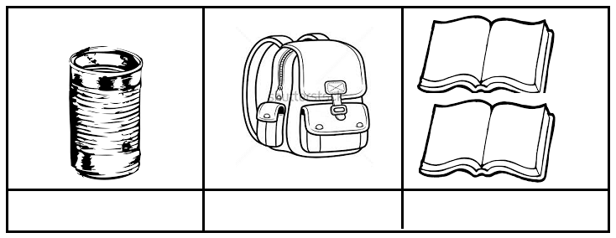

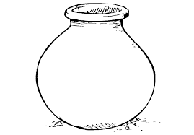

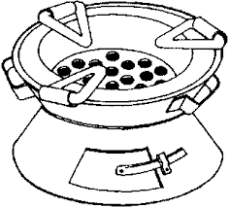



1. **Draw and colour a cook.**

**End**